Perception travel system diagram
jhanacek. net

Decentraland - temple
mid october site launch
content delivery network
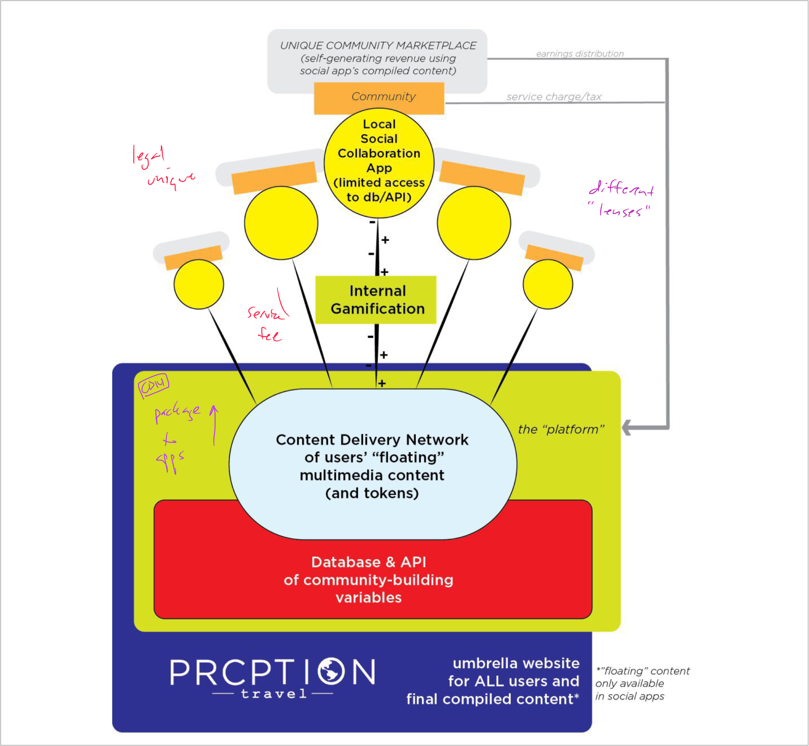
- art
- travel
- music
plus and play frontend
quick app for art
view + submit new voice → new art "remix"
swipe neighborhood
microslog app

video submit page unique fields
- 2 video submission

Database and user databaseconnected by user permissions thru" lenses"

